Project Design Phase-II
Data Flow Diagram & User Stories
Date | 16 February 2026
Team ID | LTVIP2026TMIDS44629
Project Name | Measuring the Pulse of Prosperity: An Index of Economic Freedom Analysis
Maximum Marks | 4 Marks

Data Flow Diagrams:
A Data Flow Diagram (DFD) is a traditional visual representation of the information flows within a system. A neat and clear DFD can depict the right amount of the system requirement graphically. It shows how data enters and leaves the system, what changes the information, and where data is stored.

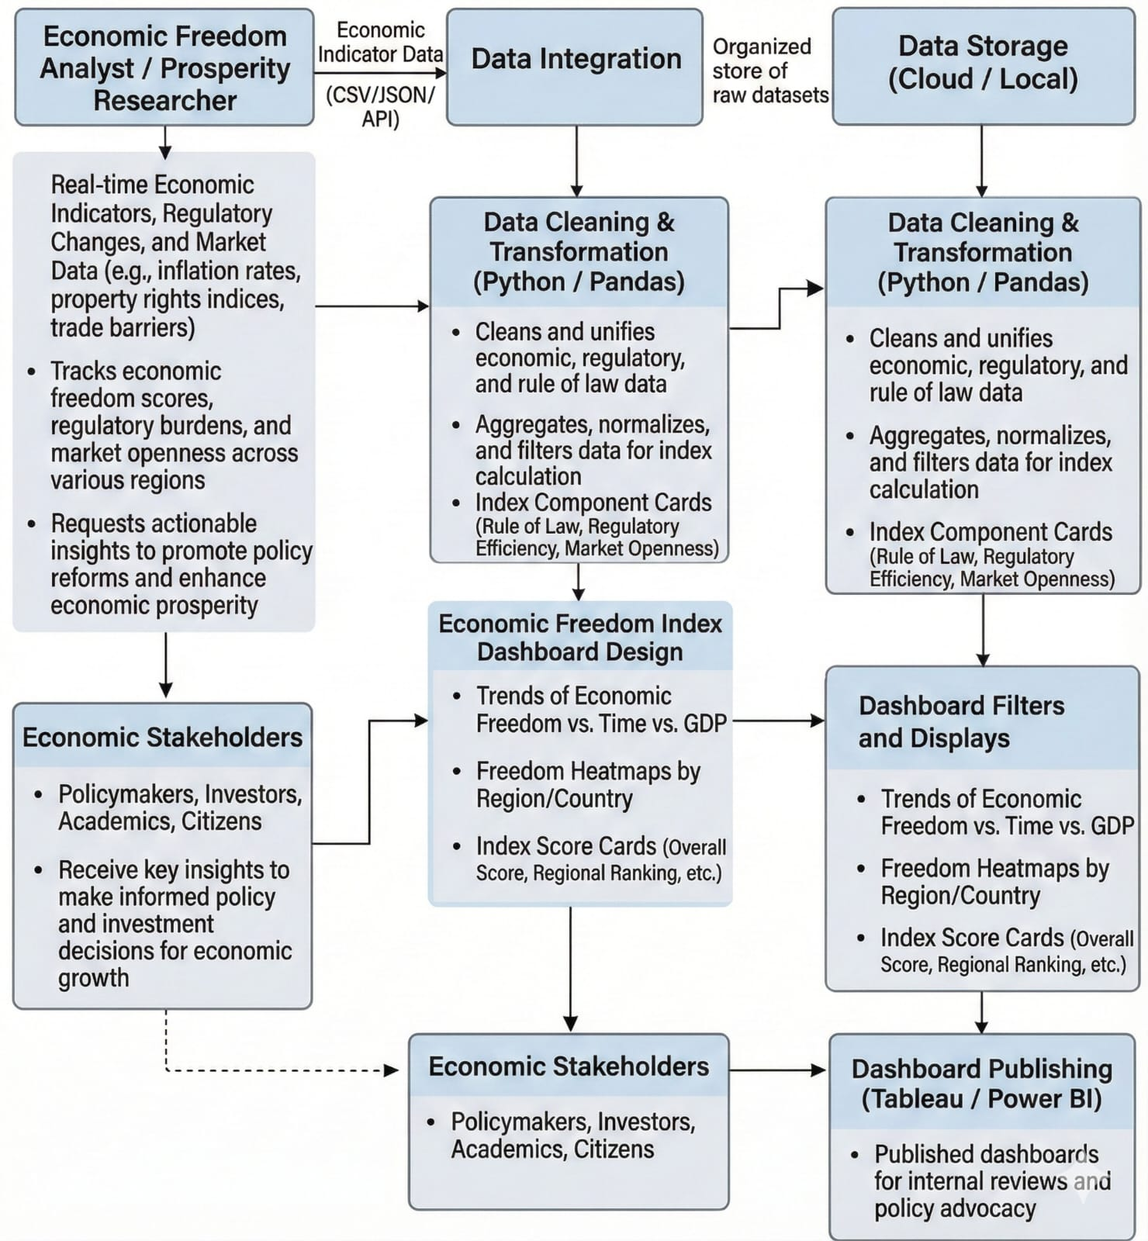
- Published dashboard for internal review and Policy advocacy

User Stories:
Use the below template to list all the user stories for the product.
User Type | Functional Requirement (Epic) | User Story No. | User Story | Acceptance Criteria | Priority | Release
Policy Analyst | Data Access & Integration | USN-1 | Import economic freedom datasets from CSV, APIs, or global databases | Data loads successfully | High | Sprint-1
Data Analyst | Data Preparation | USN-2 | Clean and standardize country names, indicators, and years | Dataset is consistent and accurate | High | Sprint-1
Researcher | Dashboard Overview | USN-3 | View overall economic freedom score and key indicators | KPI cards display accurate metrics | High | Sprint-1
Economist | Indicator Analysis | USN-4 | Compare performance across indicators (rule of law, government size, regulatory efficiency, market openness) | Visuals update accurately | High | Sprint-1
Regional Analyst | Country & Regional Comparison | USN-5 | Compare countries and regions | Charts reflect accurate comparisons | High | Sprint-1
Policy Advisor | Time-Based Trends | USN-6 | Analyze trends over years | Trend charts show correct variations | High | Sprint-1
Stakeholder | Filters & Interaction | USN-7 | Filter by region, income group, and year | Dashboard updates dynamically | High | Sprint-2
Strategy Consultant | Insight Detection | USN-8 | Identify policy strengths and weaknesses | Visual indicators highlight gaps | Medium | Sprint-2
Senior Official | Reporting | USN-9 | View story-driven insights | Story view summarizes key insights | Medium | Sprint-2
System Admin | Publishing & Access | USN-10 | Publish dashboard securely | Role-based access enabled | Medium | Sprint-2

